TEST REPORT

TESTER NAME : HỒ CÔNG PHÙNG

MSSV : 18021014
CODE : https://github.com/egonSchiele/grokking_algorithms

FUNCTION TEST : QUICKSORT

PURPOSE : USING QUICKSORT TO SORT AN ARRAY

Source code :

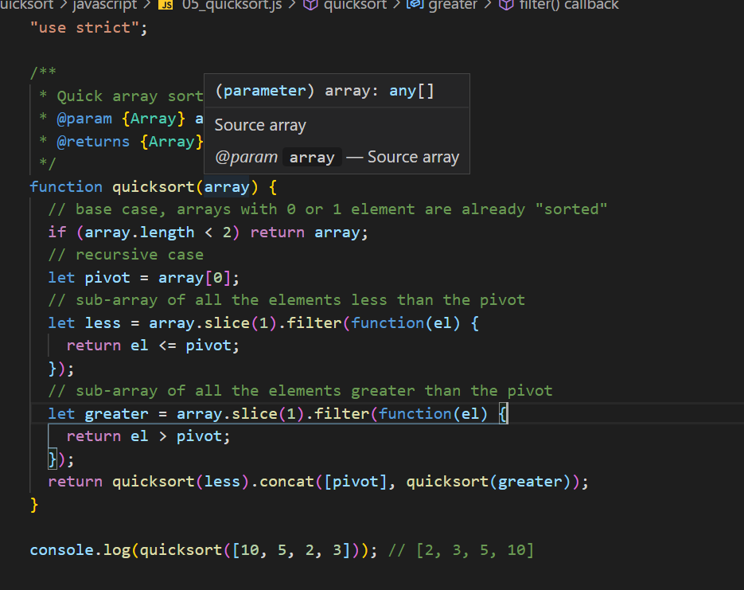

Graph :

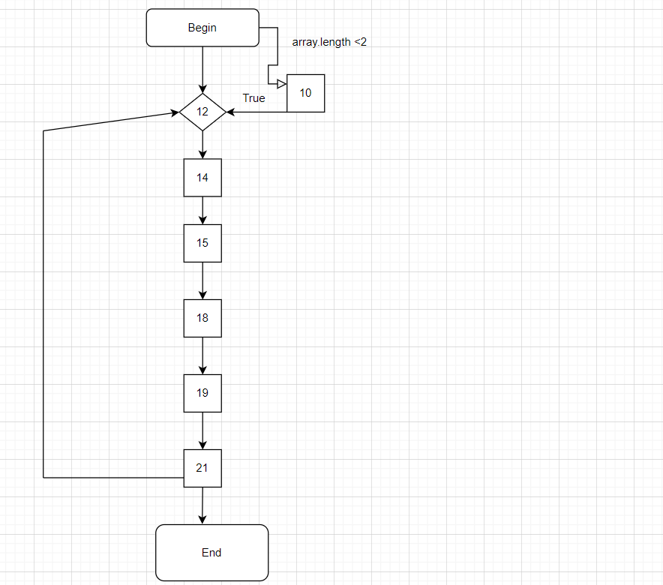

Control Flow Graph

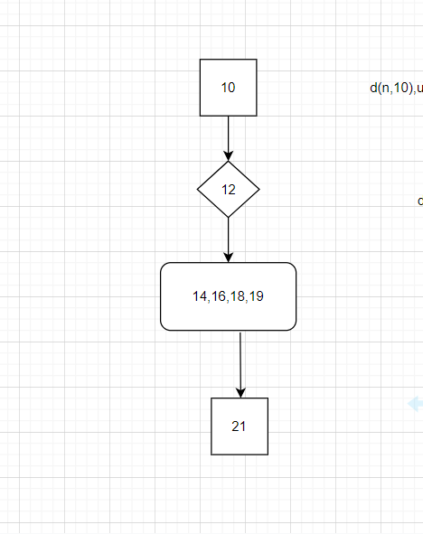

Data Flow Graph

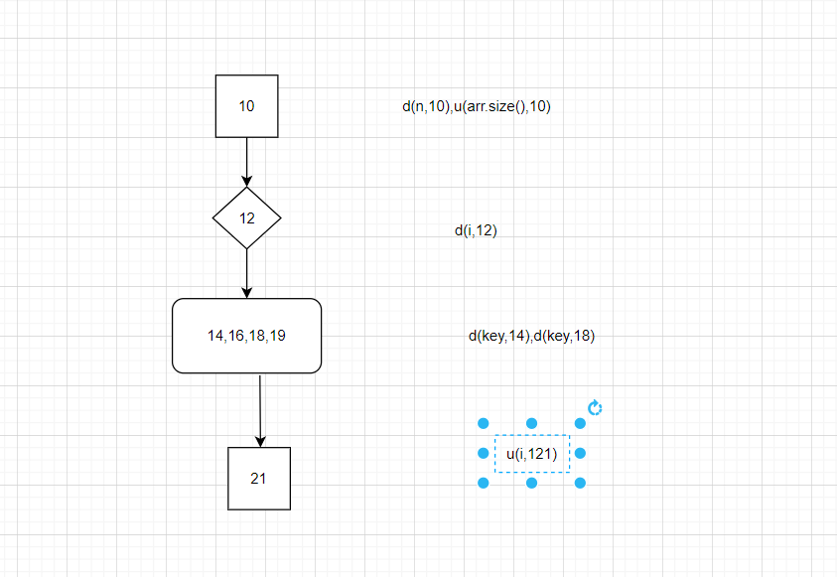

All-DU-Paths coverage testcases :

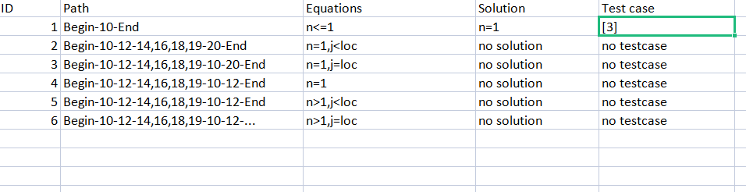

Test cases :

